**Realtek EPON HGU Products**

**4FE+WIFI+CATV/4FE+WIFI/1GE+WIFI/1GE+WIFI+CATV/4GE+WIFI+CATV/4GE+WIFI**

**User Manual**

**Version：V1.1**

**Content**

1 Note 1

1.1 Installation Precautions 1

1.2 Precautions for Use 1

2 Brief 3

2.1 Product Features 3

2.2 Product Specifications 4

2.3 Device Interface Definition 4

2.4 LED Description 5

2.5 Device Connection 5

2.6 Applications 6

3 Login Web Management Locally 6

3.1 Physical Connection of ONU and PC 6

3.2 PC Access the WEB of ONU 7

4 ONU Register Information Config 8

4.1 View ONU Register Status 8

4.2 View ONU Optical Power Information 8

4.3 LOID Authentication Config 9

5 Basic Configuration for Internet 9

5.1 Route Mode Configuration 9

5.2 Configure Bridge WAN Connection for Internet 15

5.3 View the WAN Connection Status 16

5.4 Delete the WAN Connection 17

6 ONU LAN Configuration 17

6.1 LAN IP Address Configuration 17

6.2 View LAN Client 18

7 Multicast/IPTV Configuration 19

7.1 Multicast/IPTV Service Setting 19

7.2 IGMP Snooping Setting 19

7.3 IGMP Proxy 20

7.4 IGMP VLAN Configuration 20

8 WLAN Configuration 20

8.1 WLAN Basic Configuration 20

8.2 WLAN Password Configuration 21

8.3 WLAN Virtual SSID 22

9 CATV Configuration 22

9.1 Configure CATV Port Parameter 22

9.2 View CATV Information 23

10 TR069 Remote Management 23

10.1 Configure Channel for TR069 Remote Management 23

10.2 TR069 Client Configuration 24

11 Device Management 24

11.1 ONU Remote Access Configuration 24

11.2 Restore Default Setting 25

11.3 Firmware Upgrade 25

11.4 Device Reboot 26

Concluding Remarks 26

# Note

## Installation Precautions

* Do not place the equipment near flammable or conductive items, high temperatures (such as direct sunlight) or in wet conditions, or on a PC chassis, and check that the surrounding appliances are stable.
* Check the cable for aging. Check and verify that the AC or DC input voltage is within the permissible range of the device and that the polarity of the DC is correct.
* Unless the manufacturer permit, use the type of power indicated on the label and the adapter supplied with the product.
* To prevent damage to the product from lightning, make sure that the ground of the power outlet and the power adapter is securely grounded. In the thunderstorm, be sure to unplug the power and all the connections.
* Equipment input voltage fluctuation should be less than 10%, the power plug, refrigerators, hair dryer and iron should not use the same socket.
* To avoid electric shock or fire due to overload of the power outlet, damage to the cord or damage to the plug, check the power cord regularly. If damage is found, replace it immediately.
* Please place the device on a flat surface and can not place items on the device.
* Equipment is easy to produce heat when working, should maintain the appropriate cooling space to avoid damage caused by overheating products. The elongated hole on the shell is designed for heat dissipation. Keep the ventilation clean and avoid falling from the heat sink into the equipment. Otherwise, the equipment may be damaged or fire. Do not spill liquid onto the surface of the equipment.

## Precautions for Use

* Please read the user manual carefully before using the equipment and follow all the precautions on the user manual and the product.
* Avoid eye looked at the optical interface directly, so as to avoid the laser beam emitted by the interface damage the eyes. Please try to wear safety glasses to effectively protect your eyes from damage. It is best to plug in the fiber optic interface jacket when the optical interface is not in use .
* Turn off the power when the device is not in use
* Before plugging the power supply, make sure that the power switch is turned off to avoid surge. Be careful when unplugging the power supply and the transformer temperature may be high.
* To ensure safety, do not open the enclosure of the device, especially when the device is powered up.
* Unplug the power supply before cleaning the equipment. Use a soft dry cloth to clean the equipment to avoid the use of liquids or sprays.
* Do not connect this product to any electronic product unless it is instructed by our customer engineer or your broadband supplier, as any incorrect connection may cause power or fire hazard.

# Brief

Realtek EPON HGU (HomeGateway ONU) series products are for telecommunications, radio and television operators FTTH fiber household type multiple access requirements and design a series of fusion EPON terminal product, the product is based on mature and stable, cost-effective gigabit EPON technology, is a blend of correlates and gigabit Ethernet switching technology, HFC technology, WLAN technology and powerful routing forward technology.High bandwidth, high reliable, easy to management and good quality of service (QoS) guarantees etc, equipment technical performance meet IEEE802.3 ah, China telecom EPON equipment technical requirements (V2.1 & V3.0) such as the requirement of the specification, with the mainstream manufacturers bureau OLT (Huawei, ZTE, Fiberhome) together used have good compatibility.

EPON technology is a combination of PON technology and Ethernet technology advantages of emerging technologies, is a kind of point to multi-point forming technology.High bandwidth, high efficiency, large coverage, and the numerous advantages of abundant user interface, etc., is the operator to realize broadband access network business, and the comprehensive transformation of the ideal technology.

Realtek EPON HGU (HomeGateway ONU) series products can be integrated wireless capabilities, fully in accordance with 802.11 n/b/g wireless standard protocols, built-in high gain directional antenna, wireless transmission rate of up to 300 MBPS, has the characteristics of strong penetrating power, wide coverage, to provide users with more efficient data transmission security.

## Product Features

* Support double fiber access, offer a variety of broadband, VOIP, CATV business
* ONU meet the IEEE802.3 ah, China telecom CTC 2.1 & CTC3.0 standards
* Wi-Fi series meet 802.11 n/b/g technical standards,support 20Mhz/40Mhz
* Support the PPPoE, DHCP, static IP broadband access
* Support NAT, static routing, port forwarding
* Support data encryption, VLAN passthrough and VLAN tag
* Support has bandwidth speed limit function
* Support port loop detection/port link-state detection function
* Support through the OLT remote upgrade/WEB local upgrade function
* Support broadcast storm inhibition function
* Isolation between different data port
* Support port flow control
* Support based on OLT as SNMP agent - each manufacturer of a unified network management, easy to install and maintain
* Provide abundant fault alarm function, easy to fault diagnosis
* Support AES - 128, support for key generation and switch
* Support technology based on the DBA and priority of dual management model, to ensure that the user specified minimum bandwidth requirements
* Support CATV business remotely shut off function
* Operating wavelength: 1100 - 1600nm
* Light reflection loss: >45dB
* Input optical power: -18dBm～0dBm

## Product Specifications

Ambient temperature: 0°C～50°C

Relative humidity： 10% to 90% (non-condensing)

Power adapter input：12 V/1A

TX Optical Power：0~4dBm

RX Opitcal Power：-3~-27dBm

## Device Interface Definition

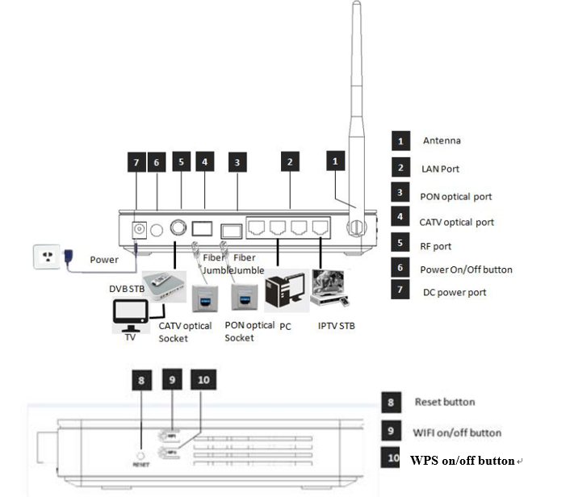

## LED Description

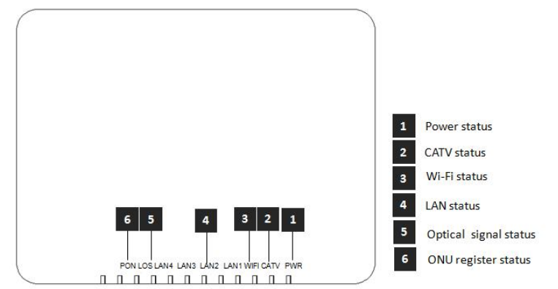

|  |  |  |  |
| --- | --- | --- | --- |
| **Indicator** | | | **Description** |
| 1 | PWR | Power status | On: The ONU is power on;  Off: The ONU is Power off; |
| 2 | CATV | CATV port status | On：CATV optical normal（>-9dBm）  Off：The CATV signals are not received（<-9dBm） |
| 3 | WIFI | WIFI | Blinking：Data is being transmitted  On：Wi-Fi function Opens |
| 4 | LANn | LAN port status | On: Ethernet connection is normal;  Blinking: Data is being transmitted  through the Ethernet port;  Off: Ethernet connection is not set up; |
| 5 | LOS | GPON optical signals | On: Optical power lower than receiver  sensitivity ;  Off: Optical in normal |
| 6 | PON | ONU Register | On: Success to register to OLT;  Blinking: In process of registering to  OLT;  Off: In process of registering to OLT; |

## Device Connection

* Connect the fiber: Insert the SC fiber connector into the PON connector on the rear panel of the ONU.
* Connect the Ethernet cable: Connect the RJ-45 Ethernet cable to any LAN port and each home device, that is, the computer, IPTV set-top box, and so on.
* Connect coaxial cable: Connect the coaxial cable to the RF connector of the ONU.
* Connect the AC adapter: Plug the AC / DC adapter into the AC wall jack and the ONU 12V DC power jack.

## Applications

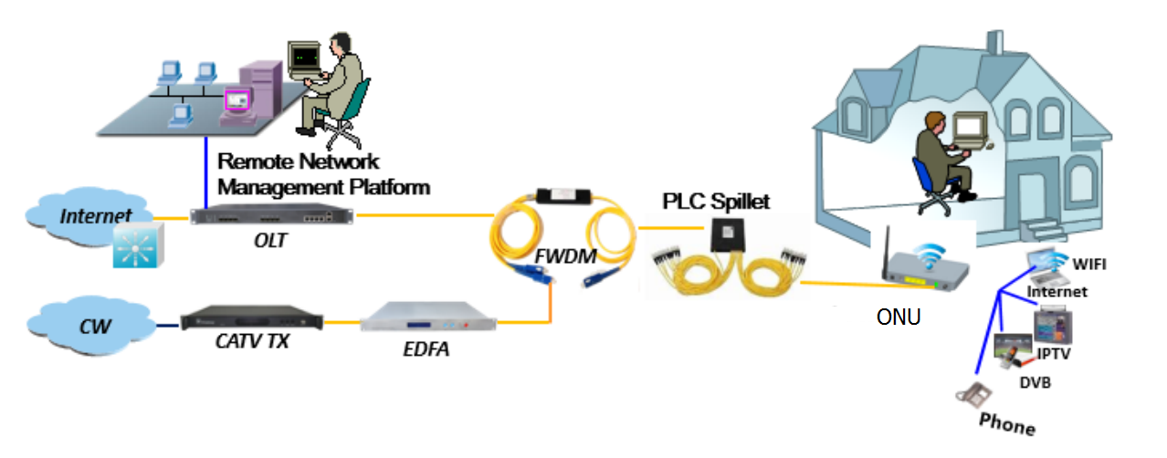

# Login Web Management Locally

## Physical Connection of ONU and PC

a) Local NIC of PC connects to LAN port or ETH port of ONU via wires.

b) Set the IP address of PC’s local NIC as **192.168.101.X (X：2-254).**

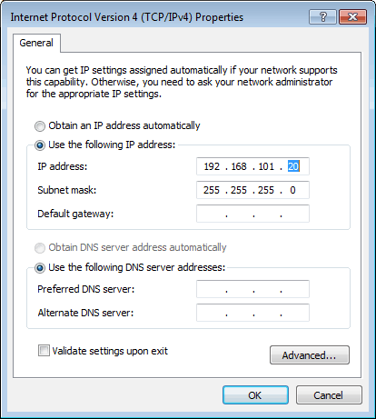

c) Open cmd windows and make sure that PC can ping the management IP (**192.168.101.1**) of ONU.

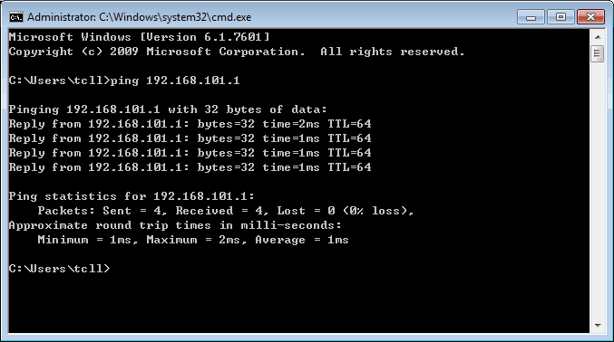

## PC Access the WEB of ONU

Make sure you can ping the ONU like #3.1. Open the **IE Web broswer (IE, Firefox, Google)**, copy and paste URL: http: //192.168.101.1, the following pop-up Prompt landin-g page:

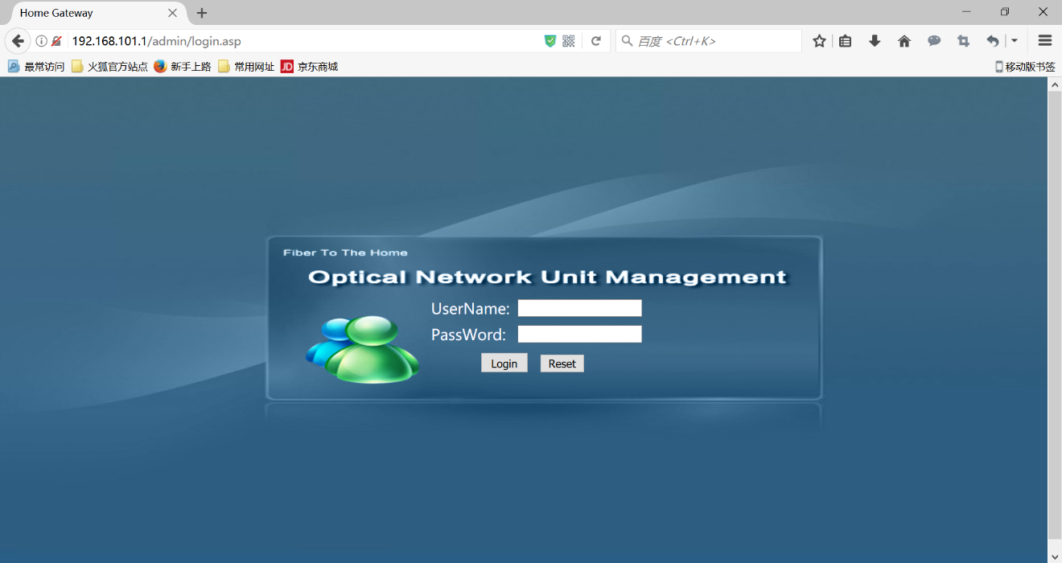

Input UserName：**adminisp** PassWord： **adminisp**

Click “**Login**” button. The product basics page appears, as follows：

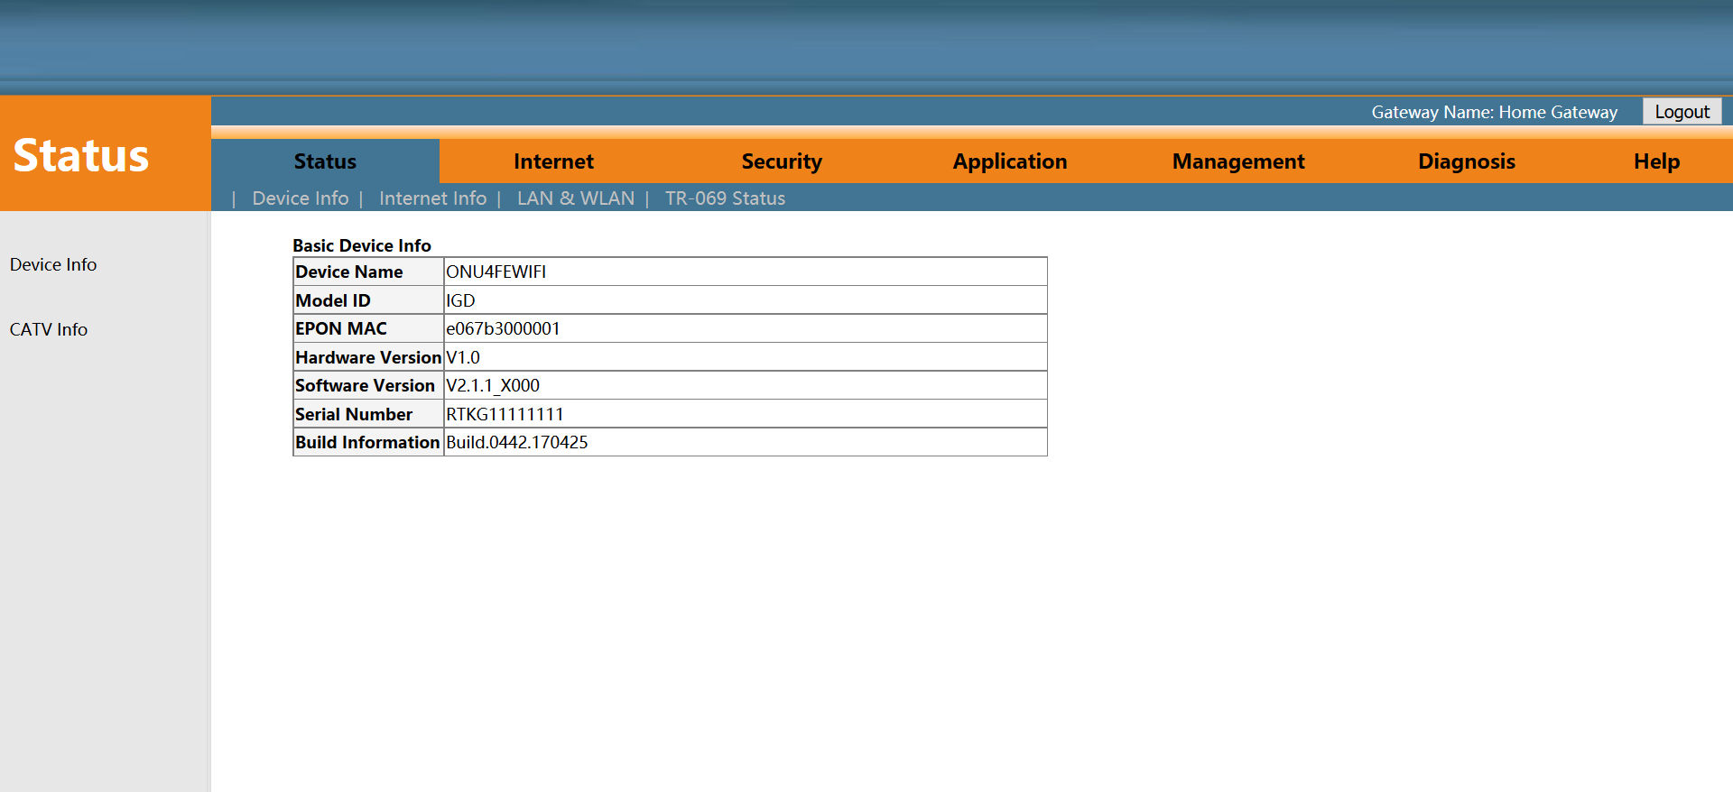

You can start further configuration.

# ONU Register Information Config

## View ONU Register Status

**1.** Login ONU WEB, select **Status -> Internet Info -> GPON Info**, view the ONU register status：

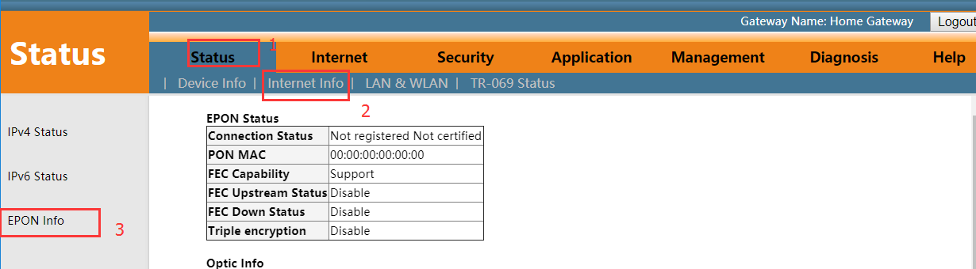

## View ONU Optical Power Information

**1.** Login ONU WEB, select **Status -> Internet Info -> GPON Info**, view Rx power and Tx power of ONU：

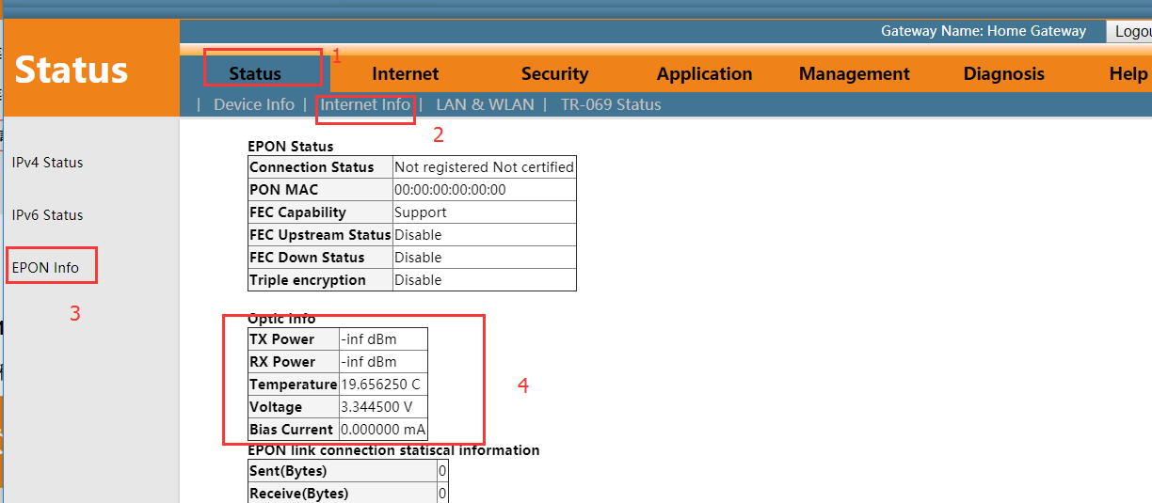

## LOID Authentication Config

LOID of ONU is mainly applicable of the authentication mode of LOID and LOID + Password for ONU. By default,EPON ONU registers for the OLT by MAC and rarely uses LOID for register. Normally, we needn’t to configure LOID. But the configuration as follows:

**1.** Login ONU WEB, select **Internet -> Remote Mgmt -> LOID**, view or configure LOID and password of ONU：

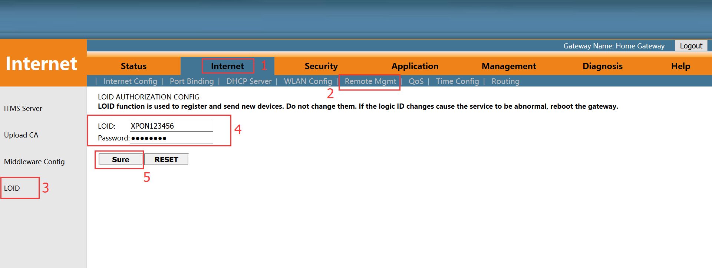

# Basic Configuration for Internet

Home Gateway Unit (HGU) ONU supports route function, so that there are route mode and bridge mode for internet. The difference between route mode and bridge mode as follows :

**Route mode：**ONT as a home gateway equipment, ONT IP address can be obtained in three ways, which includes **DHCP**, **Static IP Address** and **PPPoE**. The IP address of the device on the user side is obtained through the DHCP address pool of the ONT, or by manually setting;

**Bridge mode：**The ONT does not obtain the IP address assigned by the upper device or can not manually set the static IP address. It is used as a relay device and does not process the data. There are three ways to obtain the IP address of the user side device, namely **DHCP**, **PPPoE**, **Static IP Address**.

## Route Mode Configuration

### **Configure PPPoE WAN Connection for Internet in Route Mode**

1. Login ONU WEB, select **Internet -> Internet Config -> Internet Config**, and then there are some parameters for us to configure as follows:

【WAN Connection name】Select ‘Add WAN Connection’

【Mode】Select ‘ Route ’

【Connection Mode】Select ‘Ipv4’; If there is Ipv6 in the network, we can select ‘Ipv4/Ipv6’.

【Internet way】Select ‘PPPoE’

【NAT】Check ‘NAT’ feature；NAT is mainly used for address translation function of local network and external network. The default is checked enable status. If you do not check this option, maybe you can’t surf the internet.

【Enable Vlan】We can set this option according to your network plan. If there is vlan in the network for internet, we have to check ‘Enable VLAN’ option. If not, we needn’t check this option, which will be VLAN transparent mode.

【Vlan ID】Configure this option according to our network plan.

【MTU】The default is 1492；we have to change to lower MTU, **such as** **1400**, if we can ping the DNS but not access the website via WEB broswer.

【User Name】Type PPPoE account, normally offered by ISP, for Internet；

【Password】Type PPPoE password, normally offered by ISP, for Internet；

【Service Mode】Select Internet；Normally, select ‘ Internet ’ in the route mode.

【LAN DHCP Disable】Don’t check this option；Normally, Terminal , connected to the HGU ONU, will get an IP address from the ONU’s IP pool. Therefore, we needn’t check this option to get the IP address.

【Bind port】Bundel the physical ports (Lan port 1-4 and wireless) with PPPoE WAN connection.

Note: By default, all LAN ports and WIFI data are not bound by this WAN connection (a LAN and WIFI SSID can only be bound to a WAN conection at the same time).

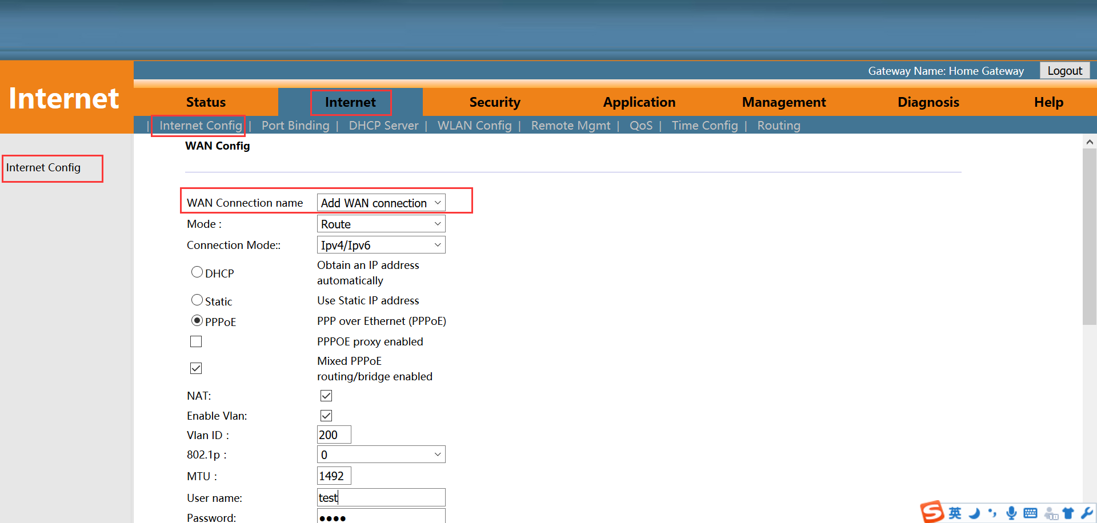

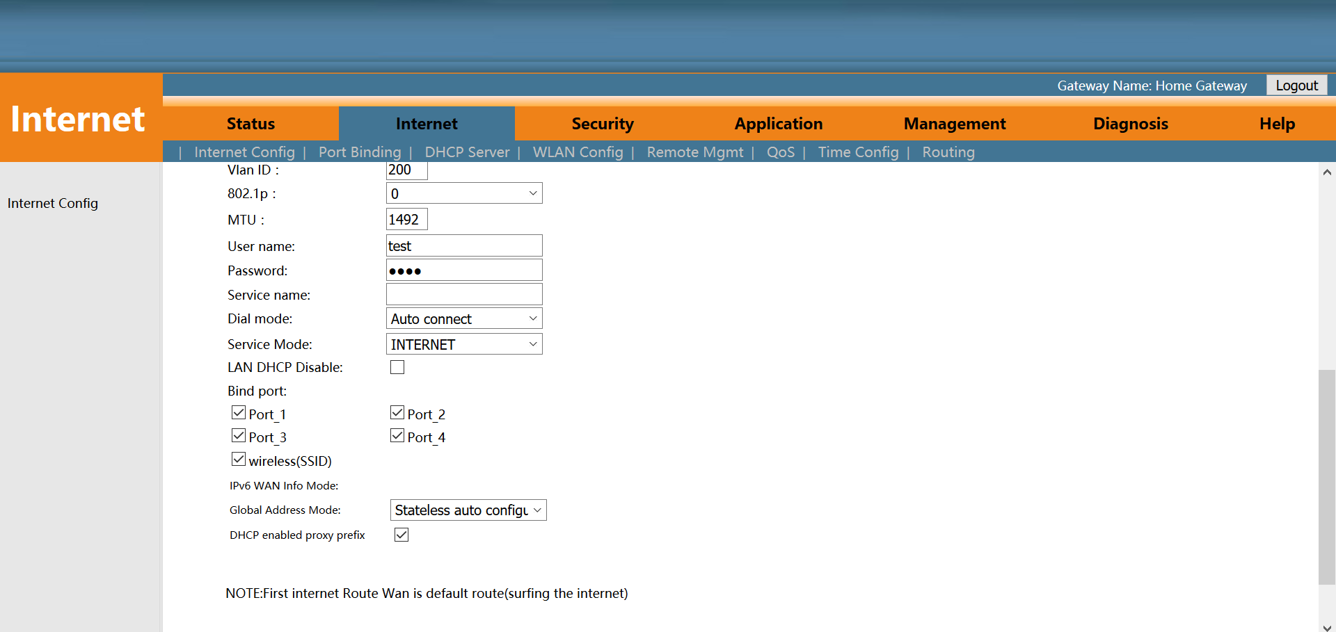

1. After configuring the parameters of PPPoE WAN connection as above, click ‘**Apply**’ to finish the setting：

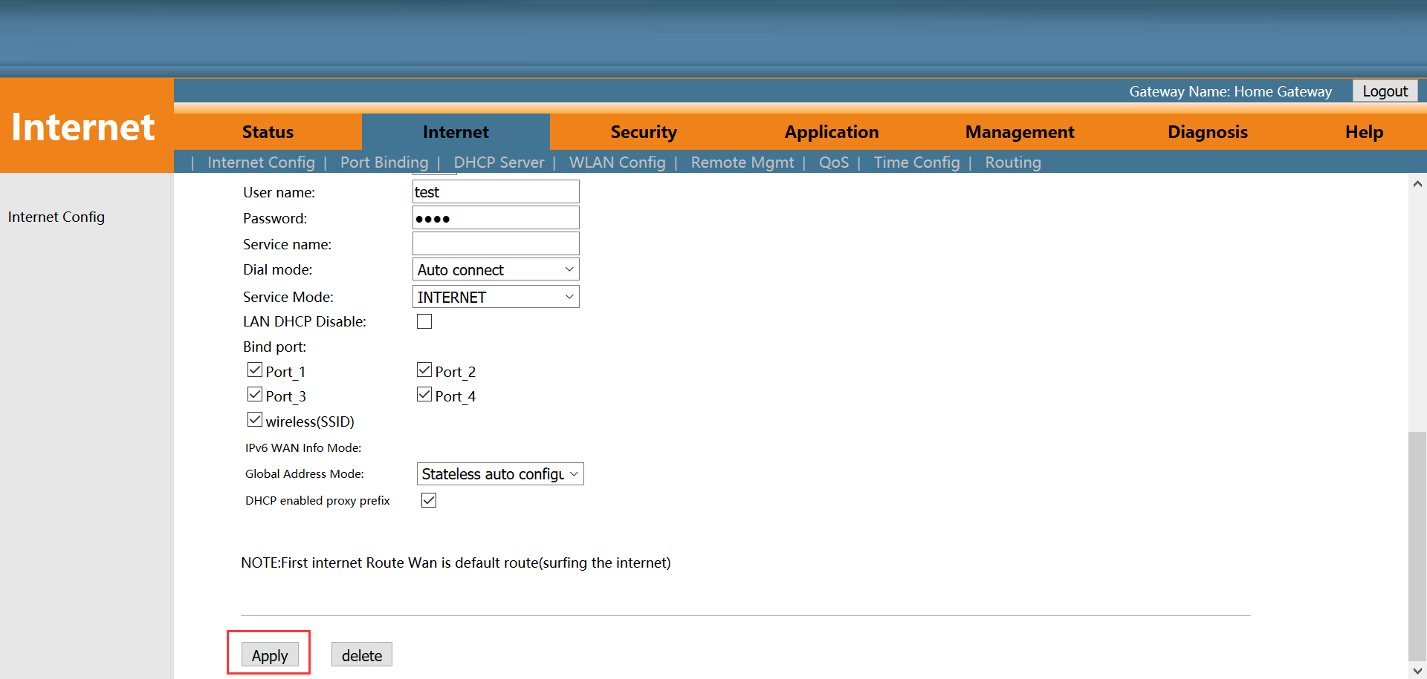

### **Configure DHCP WAN Connection for Internet in Route Mode**

1. Login ONU WEB, select **Internet -> Internet Config -> Internet Config**, and then there are some parameters for us to configure as follows:

【WAN Connection name】Select ‘Add WAN Connection’

【Mode】Select ‘ Route ’

【Connection Mode】Select ‘Ipv4’; If there is Ipv6 in the network, we can select ‘ Ipv4/Ipv6 ’.

【Internet way】Select ‘DHCP’

【NAT】Check ‘ NAT ’ feature；NAT is mainly used for address translation function of local network and external network. The default is checked enable status. If you do not check this option, maybe you can’t surf the internet.

【Enable Vlan】We can set this option according to your network plan. If there is vlan in the network for internet, we have to check ‘ Enable VLAN ‘ option. If not, we needn’t check this option, which will be VLAN transparent mode.

【Vlan ID】Configure this option according to our network plan.

【MTU】The default is 1500; we have to change to lower MTU, **such as 1400**, if we can ping the DNS but not access the website via WEB broswer.

【Request DNS】Selected ‘enable’, the ONU will get DNS from upper DNS server automatically; Selected ‘Disable’, we have to configure an static DNS for the ONU by manual. We can configure one of them according to network plan.

【Primary DNS / Secondary DNS】After disable ‘Request DNS’ function, we have to set a static DNS in here.

【Service Mode】Select Internet；Normally, select ‘ Internet ’ in the route mode.

【LAN DHCP Disable】Don’t check this option；Normally, Terminal , connected to the HGU ONU, will get an IP address from the ONU’s IP pool. Therefore, we needn’t check this option to get the IP address.

【Bind port】Bundel the physical ports (Lan port 1-4 and wireless) with DHCP WAN connection.

Note: By default, all LAN ports and WIFI data are not bound by this WAN connection (a LAN and WIFI SSID can only be bound to a WAN conection at the same time).

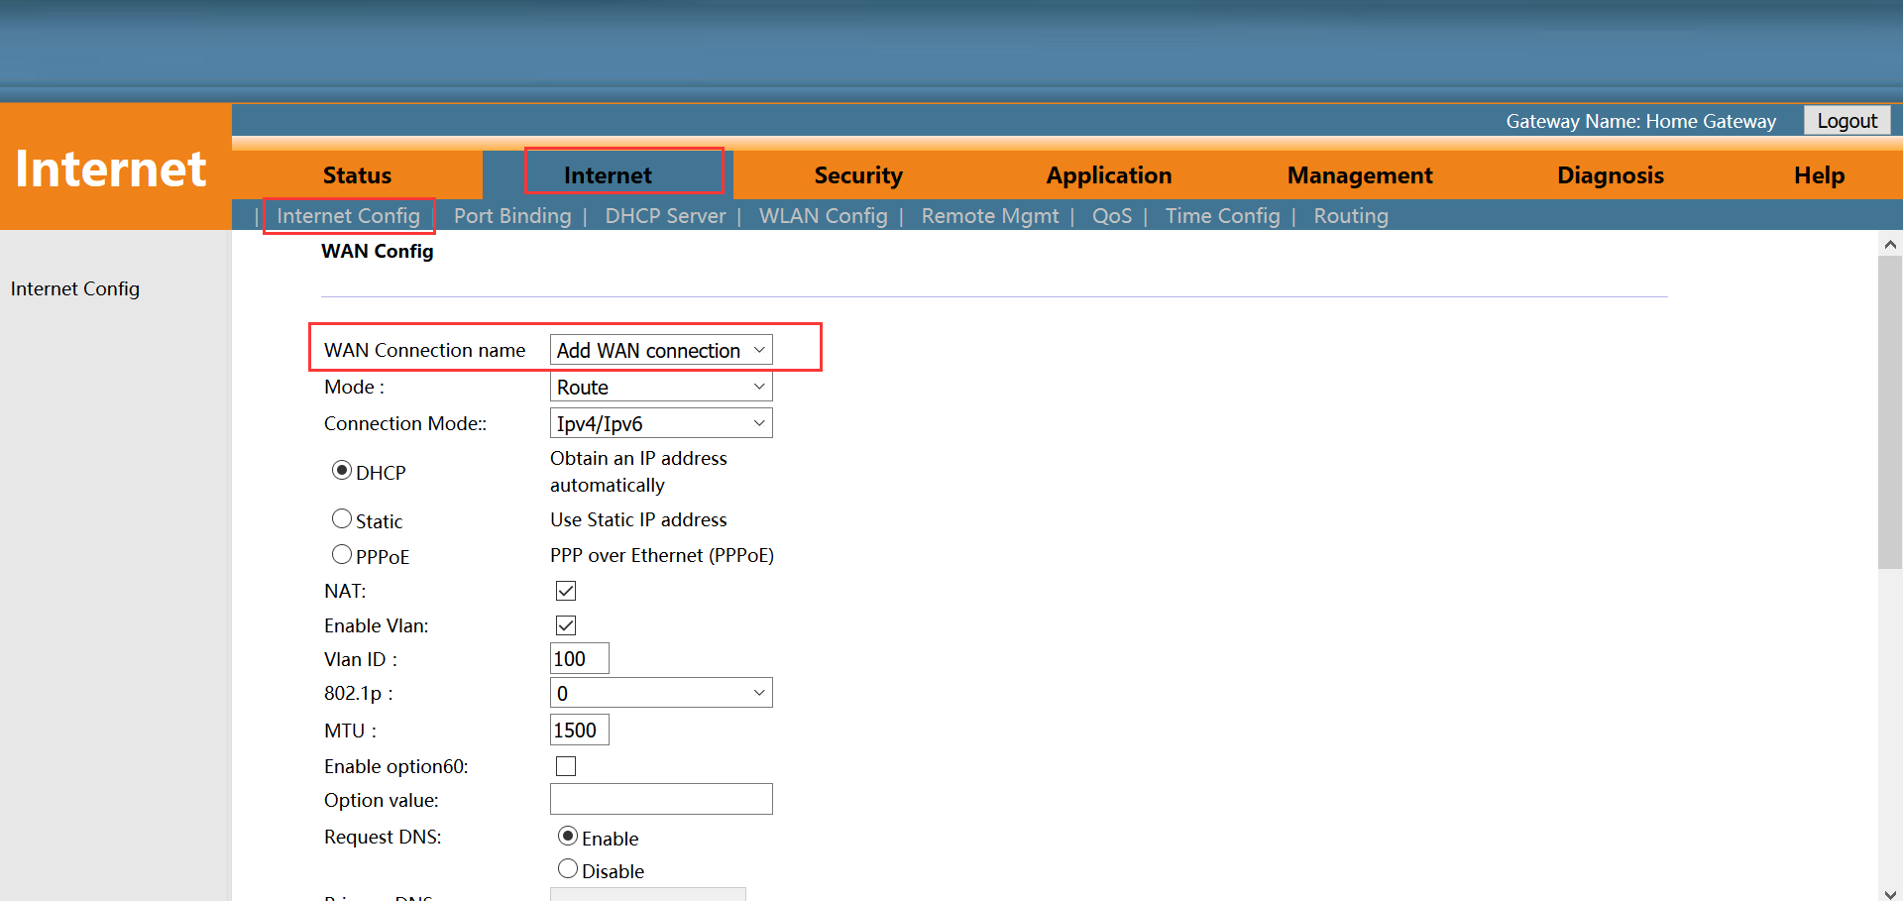

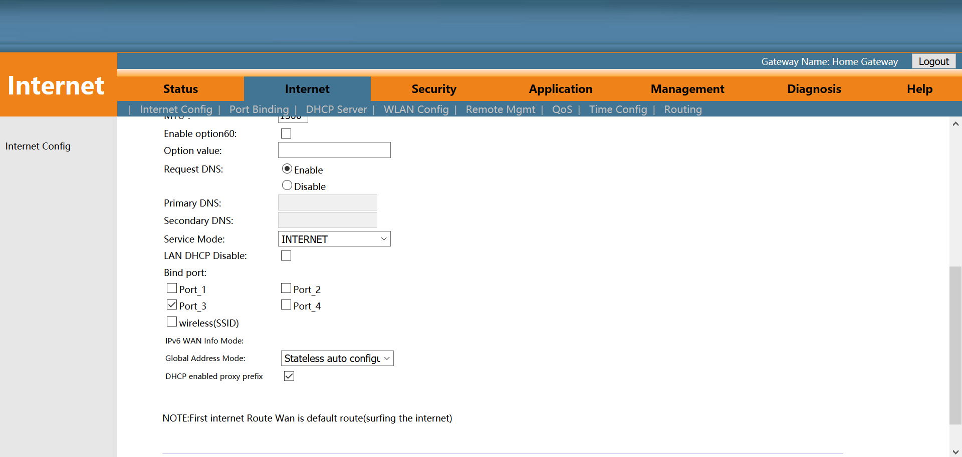

2.After configuring the parameters of DHCP WAN connection as belows, click ‘**Apply**’ to finish the setting：

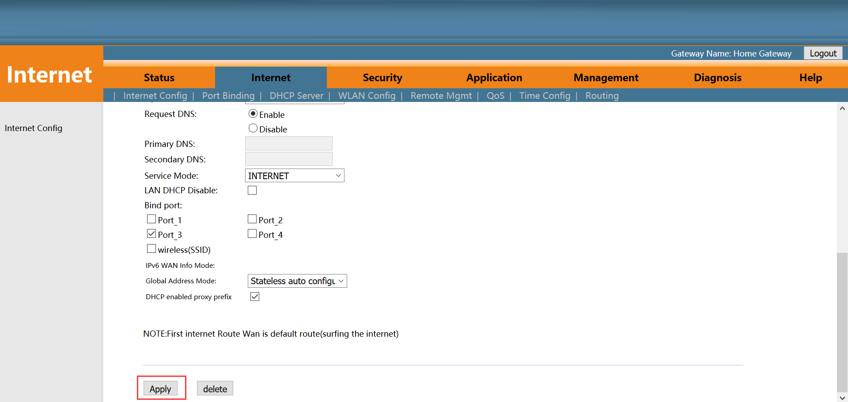

### **Configure Static IP Address WAN Connection for Internet in Route Mode**

1. Login ONU WEB, select **Internet -> Internet Config -> Internet Config**, and then there are some parameters for us to configure as follows:

【WAN Connection name】Select ‘Add WAN Connection’

【Mode】Select ‘ Route ’

【Connection Mode】Select ‘Ipv4’; If there is Ipv6 in the network, we can select ‘ Ipv4/Ipv6 ’.

【Internet way】Select ‘Static’

【NAT】Check ‘ NAT ’ feature；NAT is mainly used for address translation function of local network and external network. The default is checked enable status. If you do not check this option, maybe you can’t surf the internet.

【Enable Vlan】We can set this option according to your network plan. If there is vlan in the network for internet, we have to check ‘Enable VLAN’ option. If not, we needn’t check this option, which will be VLAN transparent mode.

【Vlan ID】Configure this option according to our network plan.

【MTU】The default is 1500；we have to change to lower MTU, such as 1400, if we can ping the DNS but not access the website via WEB broswer.

【IP Address】Set static IP address

【Subnet Mask】Set the mask of static IP address

【Default Gateway】Set the default gateway of static IP address

【Primary DNS / Secondary DNS】Set static primary DNS address and secondary DNS address

【Service Mode】Select Internet；Normally, select ‘Internet’ in the route mode.

【LAN DHCP Disable】Don’t check this option；Normally, Terminal , connected to the HGU ONU, will get an IP address from the ONU’s IP pool. Therefore, we needn’t check this option to get the IP address.

【Bind port】Bundel the physical ports (Lan port 1-4 and wireless) with Static IP WAN connection.

Note: By default, all LAN ports and WIFI data are not bound by this WAN connection (a LAN and WIFI SSID can only be bound to a WAN conection at the same time).

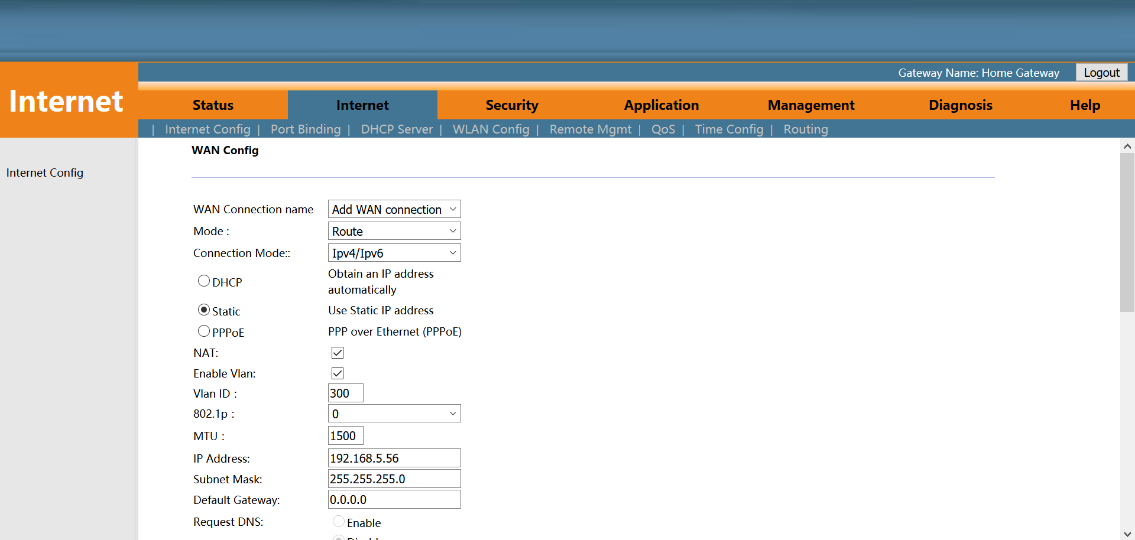

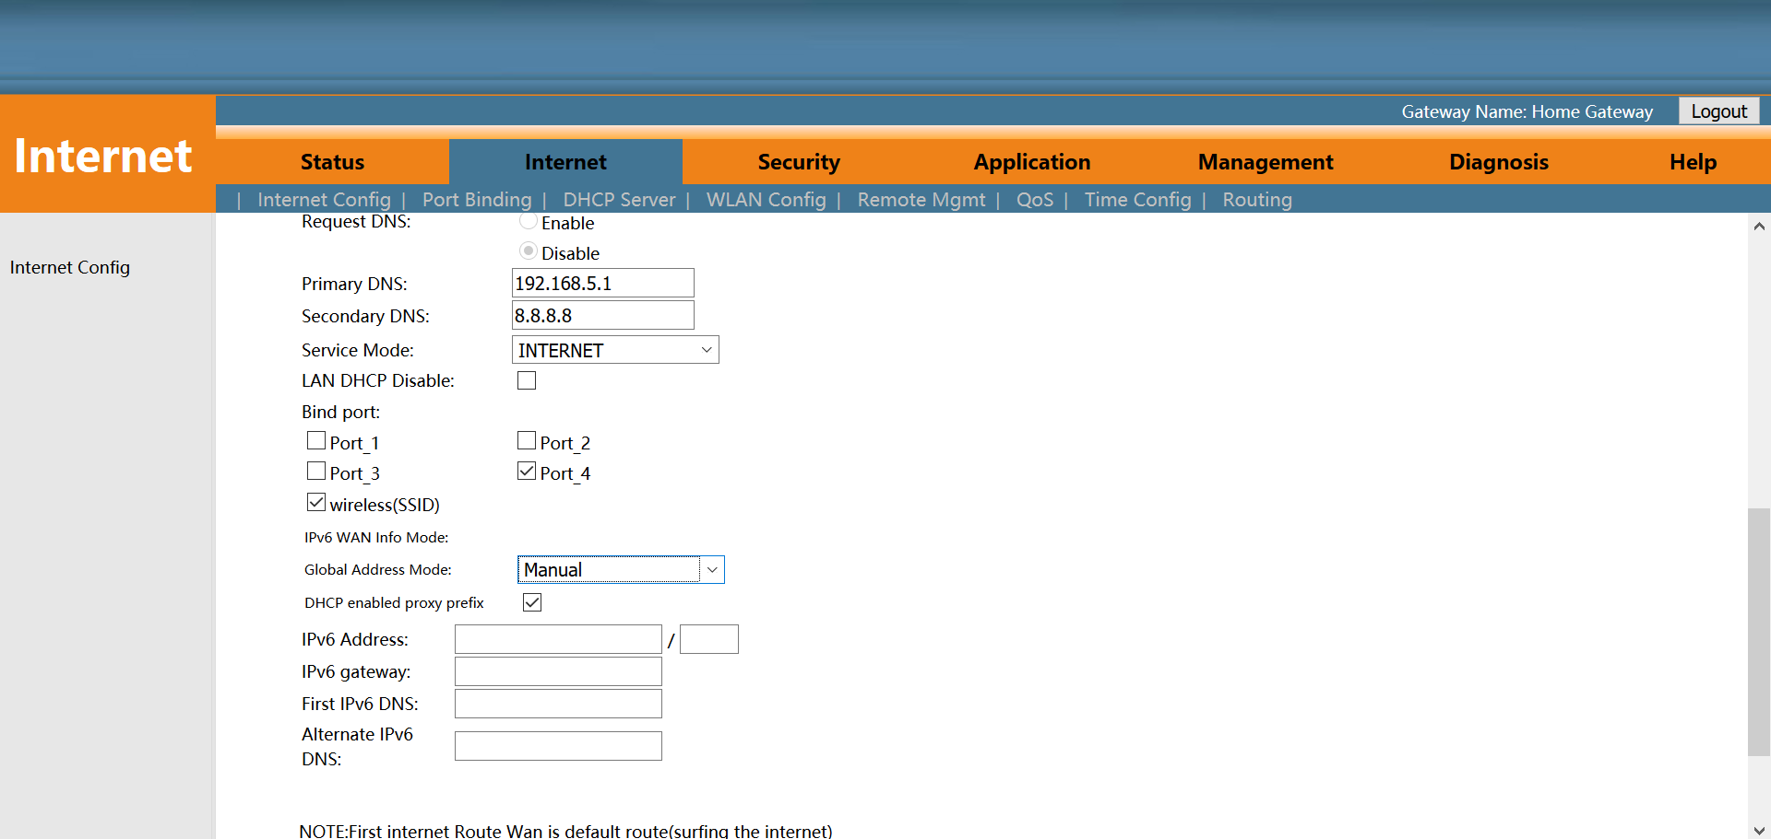

2. After configuring the parameters of Static IP WAN connection as belows, click ‘**Apply**’ to finish the setting：

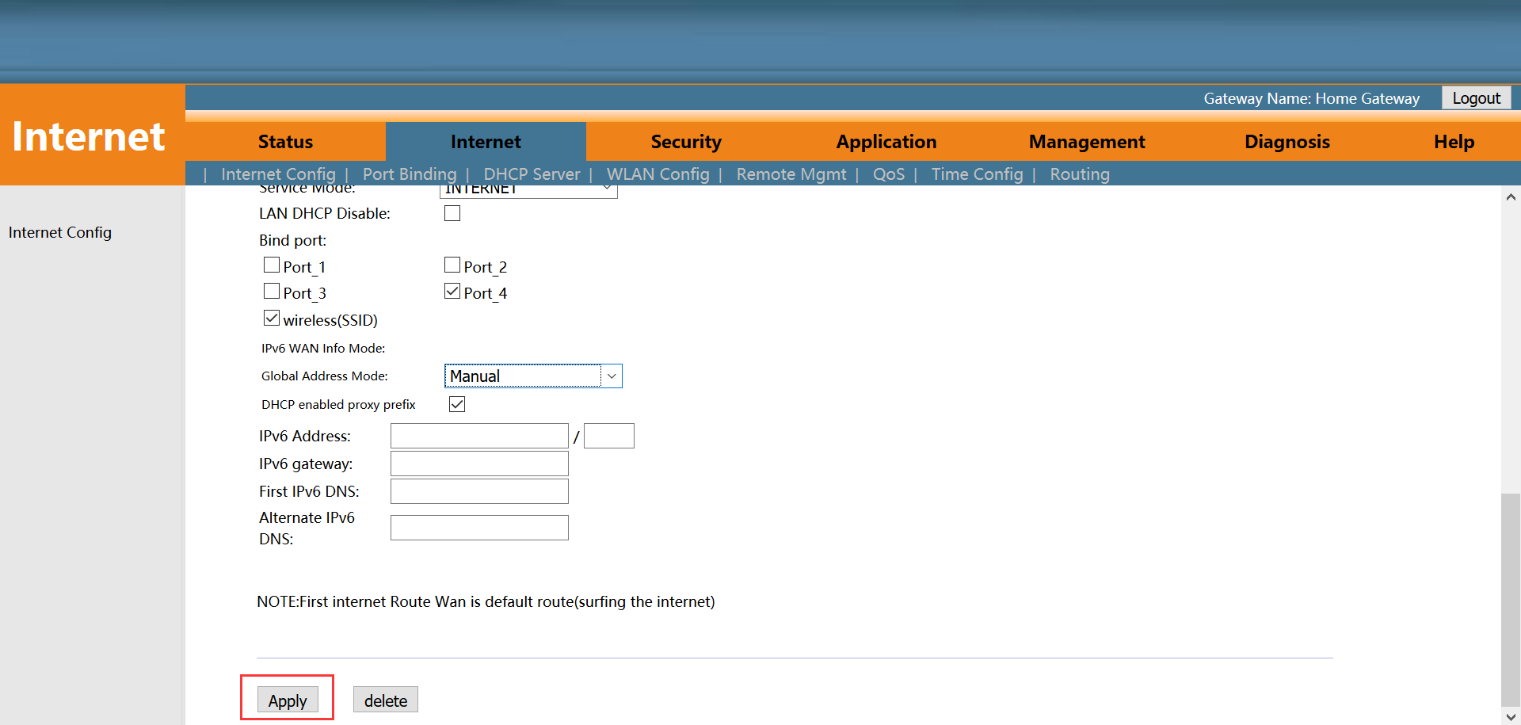

## Configure Bridge WAN Connection for Internet

1. Login ONU WEB, select **Internet -> Internet Config -> Internet Config**, and then there are some parameter for us to configure as follows:

【WAN Connection name】Select ‘Add WAN Connection’

【Mode】Select ‘Bridge’

【Connection Mode】Select ‘Ipv4’; If there is Ipv6 in the network, we can select ‘Ipv4/Ipv6’.

【NAT】 Don’t check ‘NAT’ feature；NAT is mainly used for address translation function of local network and external network. HGU ONU doesn’t deal with the packets from the teminal, so we needn’t enable the NAT function.

【Enable Vlan】We can set this option according to your network plan. If there is vlan in the network for Internet, we have to check ‘Enable VLAN’ option. If not, we needn’t check this option, which will be VLAN transparent mode.

【Vlan ID】Configure this option according to our network plan.

【MTU】The default is 1500；we have to change to lower MTU, **such as 1400**, if we can ping the DNS but not access the website via WEB broswer.

【Service Mode】 Select ‘Other’ or ‘Internet’；Normally, select ‘Internet’ for Internet or flow testing; Select ‘Other’ for IPTV service.

【LAN DHCP Disable】Check this option；Normally, Terminal , connected to the HGU ONU, will get an IP address from the upper DHCP server. Therefore, we need check this option to avoid the terminal get an IP from the ONU.

【Bind port】Bundel the physical ports (Lan port 1-4 and wireless) with Bridge WAN connection.

Note: By default, all LAN ports and WIFI data are not bound by this WAN connection (a LAN and WIFI SSID can only be bound to a WAN conection at the same time).

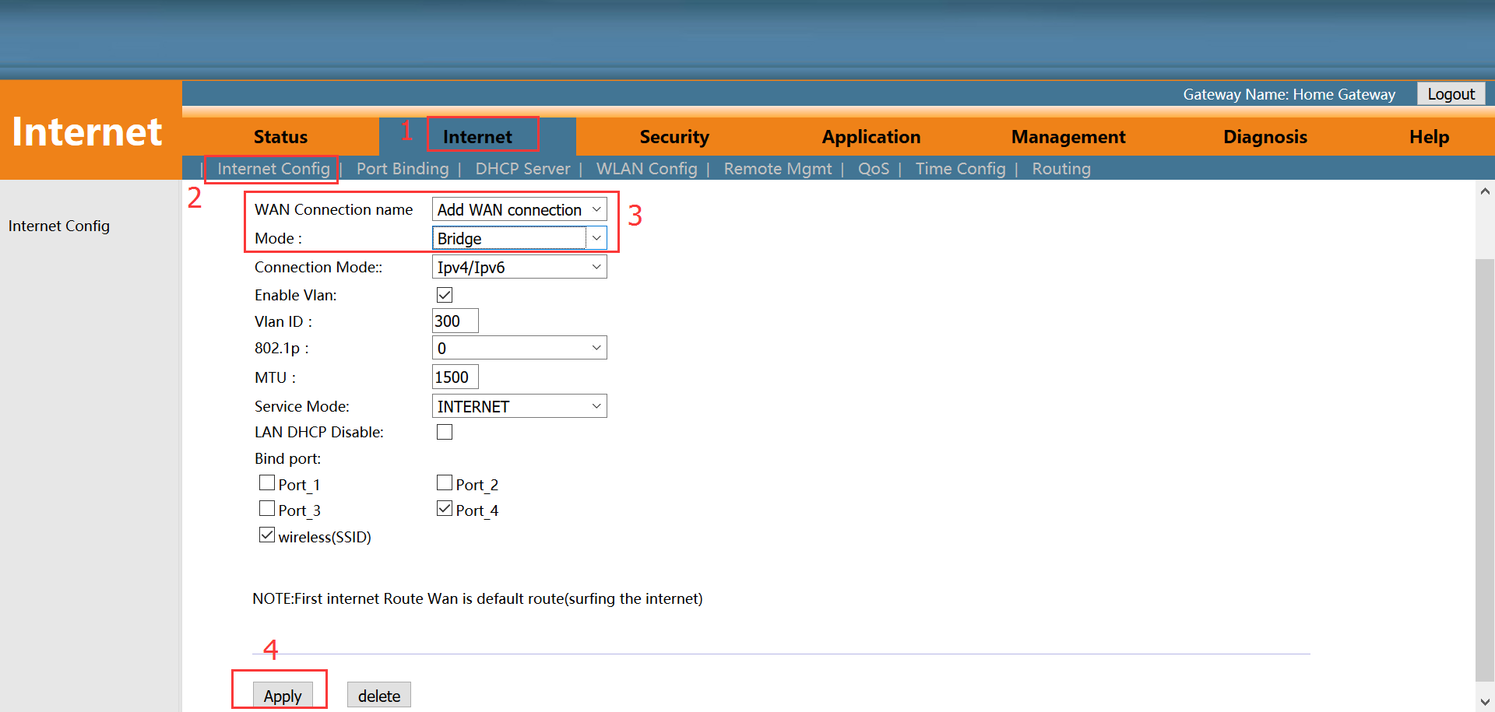

2. After configuring the parameter of Bridge WAN connection as above, click ‘**Apply**’ to finish the setting：

## View the WAN Connection Status

1. Login ONU WEB, select **Status -> Internet Info -> IPv4 Status**. In here, we can view WAN connection status, check the route WAN connection if it gets an IP address and Bridge WAN connection if it is **UP**. As follows:

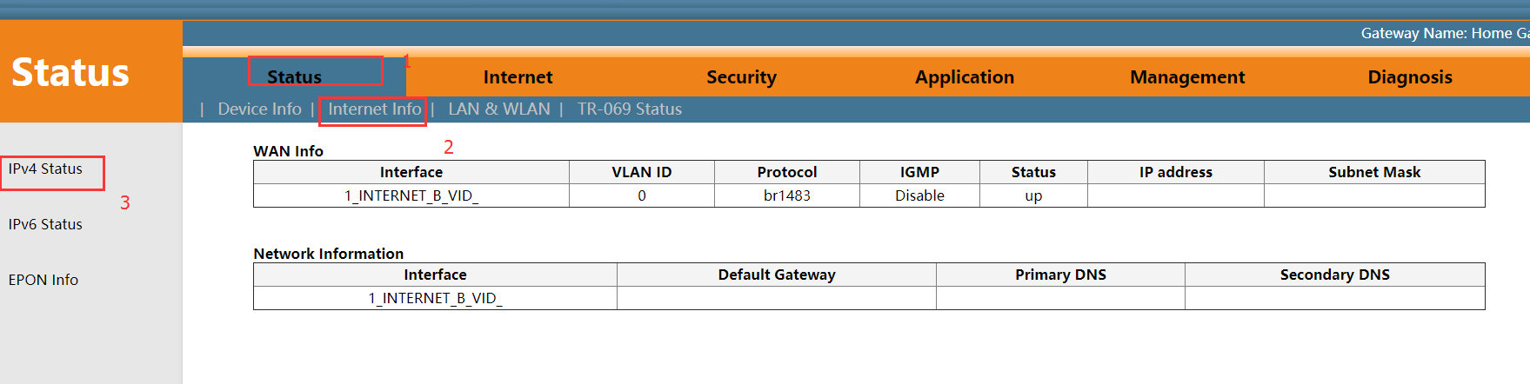

## Delete the WAN Connection

1. Login ONU WEB, select **Internet -> Internet Config -> Internet Config**. Select a WAN connection from ‘**WAN Connection name**’ and click ‘**Delete**’ button at the bottom of the page. As follows:

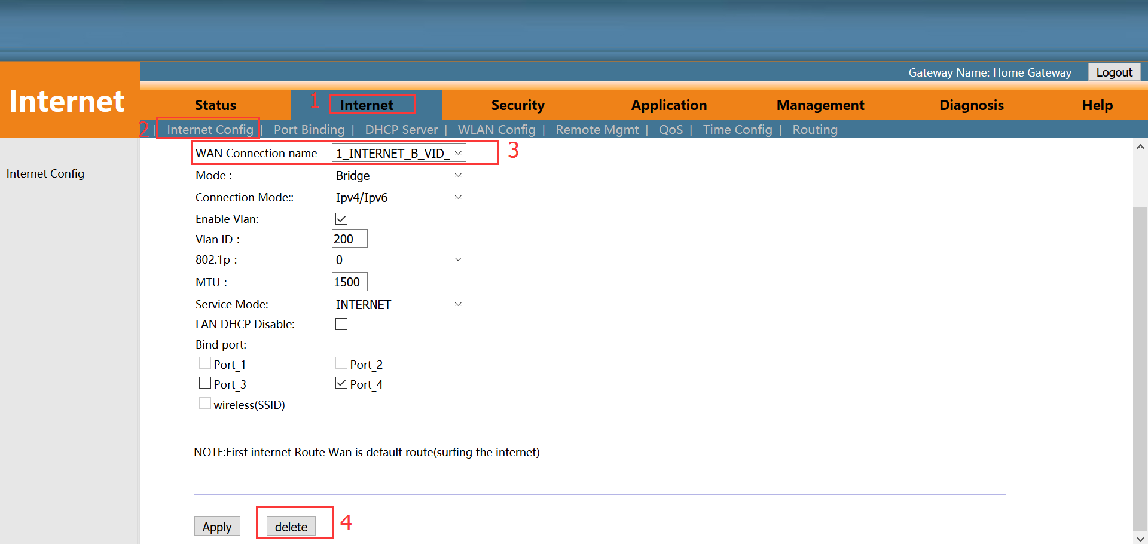

# ONU LAN Configuration

## LAN IP Address Configuration

1. Login ONU WEB, select **Internet -> DHCP Server -> IPv4 DHCP Server**, and then there are some parameters for us to configure as follows:

【IP address】Set local management IP address of ONU. The default IP address is 192.168.101.1

【Subnet mask】Set the mask of local management IP address of ONU

【Disable DHCP Server/Enable DHCP Server】Enable or disable ONU DHCP Server function.

【Start IP address / End IP address】Configure the IP address interval that allocated to the terminal. The address interval must be on the same network segment as the management IP address of the ONU.

【DNS1/DNS2/DNS3】Configure DNS address that allocated to the terminal. By default, 192.168.101.1 of DNS agent address is used to default DNS address. We can design this according to network plan.

【Edit DHCP address range】By default, the ONU will allocate 10 IP addresses for every kinds of terminal. If it is not enough, we can edit DHCP address range to increase the designed address range.

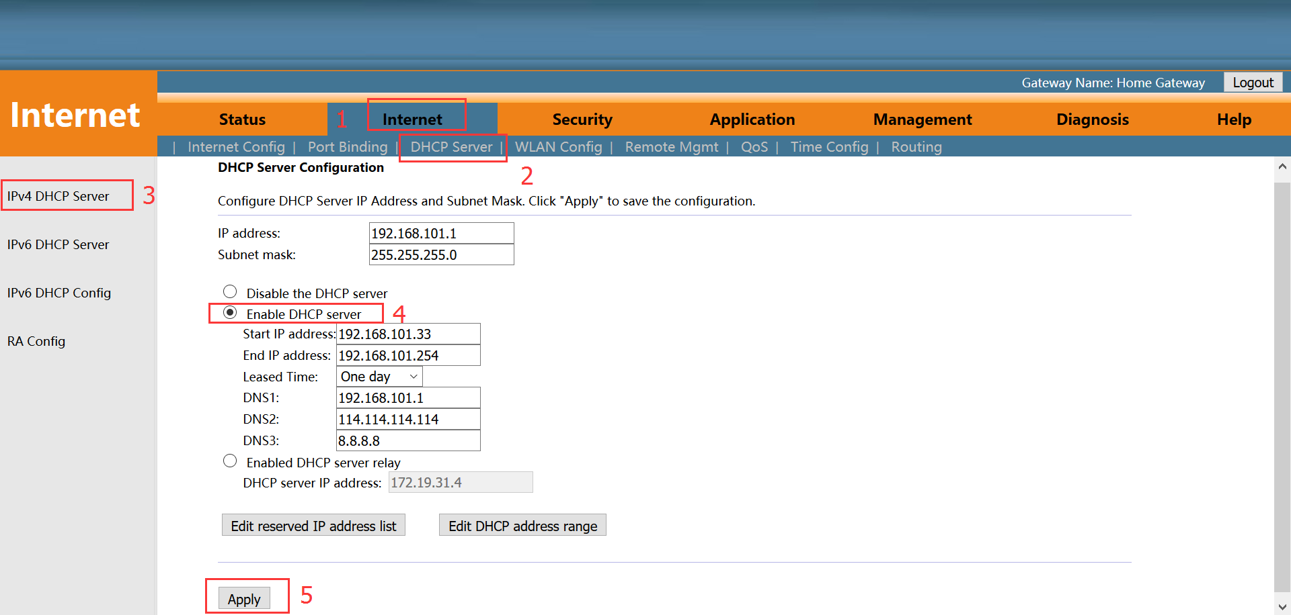

1. After configuring the parameters of LAN address as above, click ‘**Apply**’ to finish the setting：

## View LAN Client

1. Login ONU WEB, select **Status -> LAN & WLAN -> WLAN Status**. View client that access via wireless (WIFI). As follows:

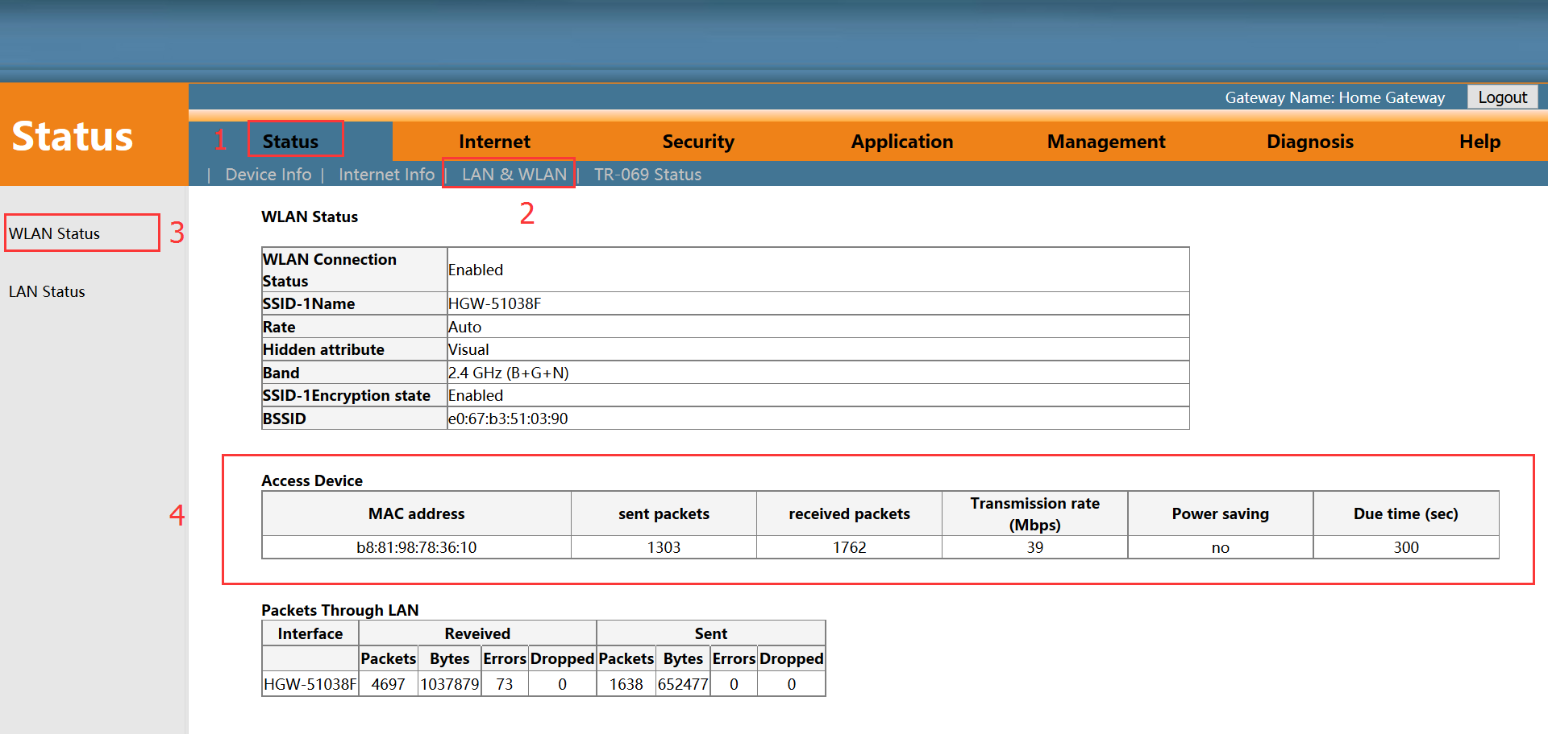

1. Login ONU WEB, select **Status -> LAN & WLAN -> LAN Status**. View client that access via LAN ports . As follows:

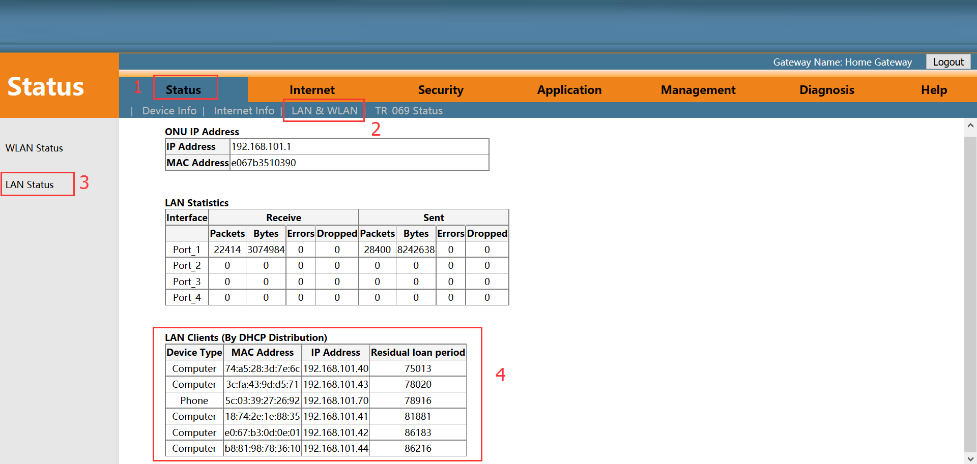

# Multicast/IPTV Configuration

## Multicast/IPTV Service Setting

Firstly, configure a bridge WAN connection to carry IGMP/IPTV service according to **#6.2** and select ‘**Other**’ in service mode. After configuring the bridge WAN connection, The configuration, related to other multicast protocols and multicast vlan, can refer to the following **# 7.2- # 7.3** configuration.

## IGMP Snooping Setting

1. Login ONU WEB, select **Application -> IGMP Config -> IGMP Snooping**. Enable or disable IGMP Snooping function and click ‘**Save/Apply**’ button to finish the setting as follows:

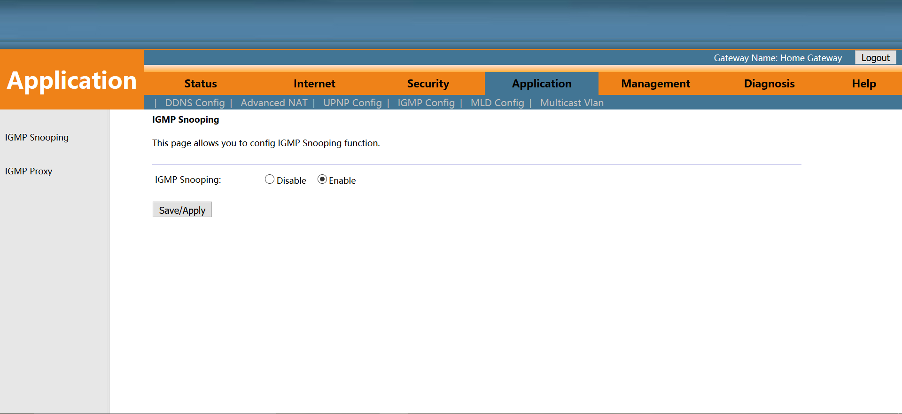

## IGMP Proxy

1. Login ONU WEB, select **Application -> IGMP Config -> IGMP Proxy**. Enable or disable IGMP Proxy function and click ‘**Save**’ button to finish the setting as follows:

Note: Normally, IGMP Proxy would be used in route mode and carrying Multicast/IPTV service, because the ONU would be acted as multicast agent. There isn’t IGMP Proxy concept in the bridge mode.

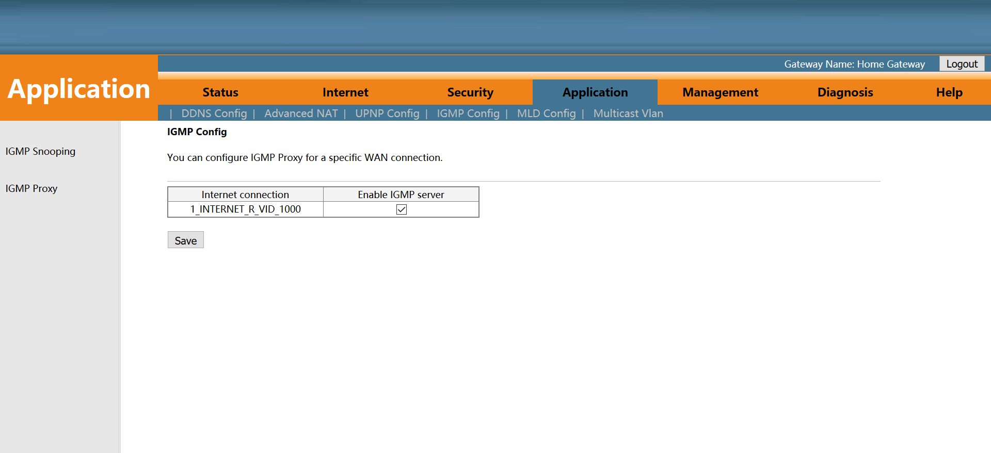

## IGMP VLAN Configuration

1. Login ONU WEB, select **Application** -> **Multicast Vlan**, select the corresponding WAN, click ‘**Modify**’, configure multicast vlan, click ‘**Modify**’ button.

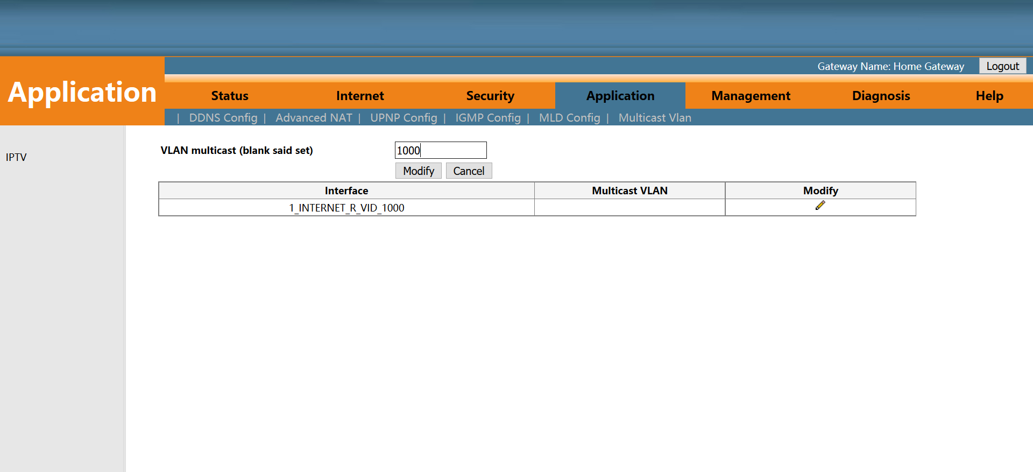

# WLAN Configuration

## WLAN Basic Configuration

1. Login ONU WEB, select **Internet**-**>WLAN Config->WLAN Config**, and then there are some parameters for us to configure as follows:

【Enable wireless】Enable or disable the wireless function；

【Virtual SSID】Click ‘**Virtual SSID**’ button to enter the virtual SSID config page；

【Band】The default is 2.4GHz（B+G+N）；

【SSID】Set wireless SSID name. Nowadays, it doesn’t support to set as Chinese SSID name.

【Bandwidth】It is best to select 20MHz, because many PC don’t support 40MHz；Sometimes, PCs can’t connect to the WIFI if we select 40MHz or 20MHz/40MHz；

【Channel】The default is Auto；We can select a channel without glitches by manual according to the surrounding environment；

【Advanced】Click ‘**Advanced**’ button and enter wirelees password config page；

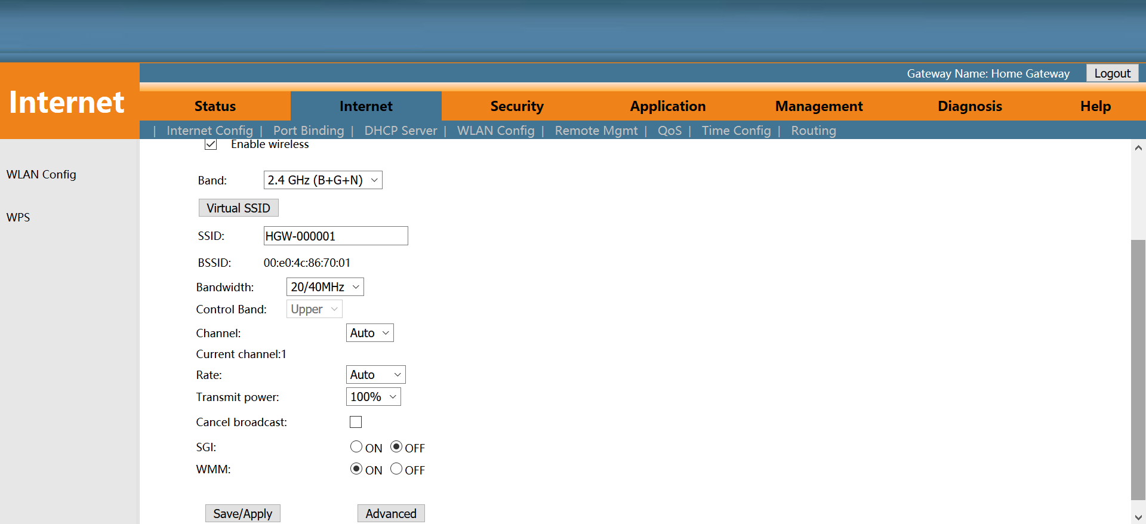

1. After setting wireless configuration, click ‘**Save/Apply**’ button to finish setting.

## WLAN Password Configuration

1. According to #**8.1**, click ‘**Advanced**’ button to enter **‘Wireless settings-Security’** page, we can set ‘Network authentication mode’ , ‘encryption’ and WIFI password.

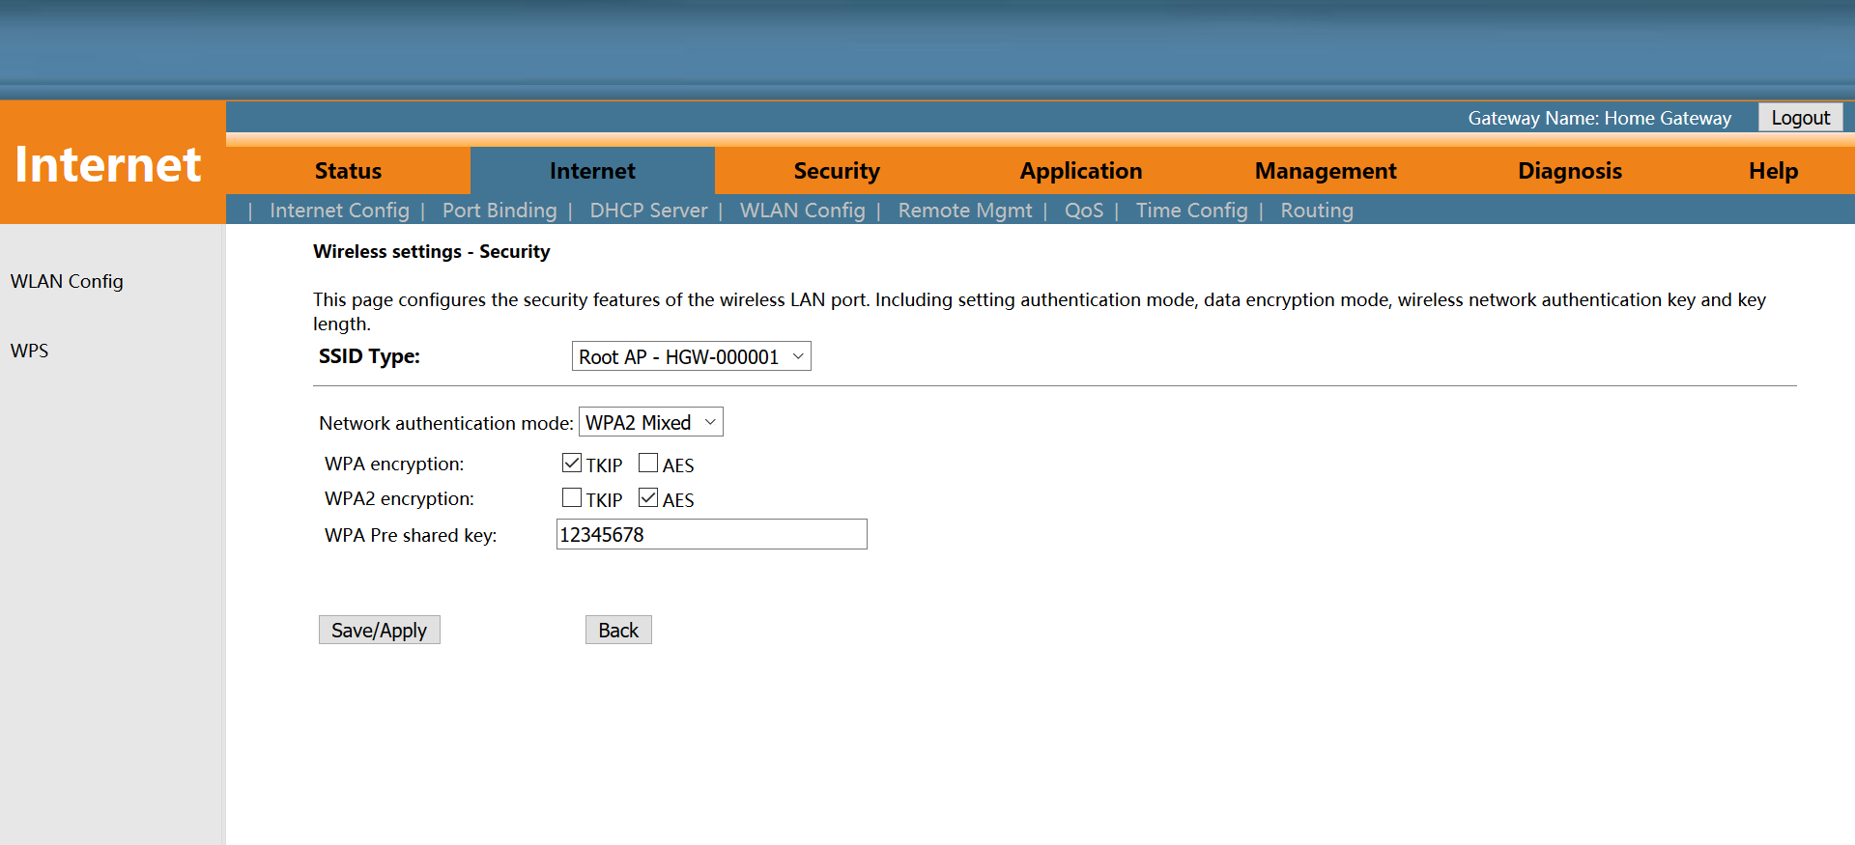

1. After setting wireless password configuration, click **‘Save/Apply’** button to finish setting.

## WLAN Virtual SSID

1. Login ONU WEB, select **Internet**-**>WLAN Config->WLAN Config**, and then click **‘Virtual SSID’** button to enter ‘**Virtual SSID**’ page. We can enable some of virtual SSID, set band and name them:

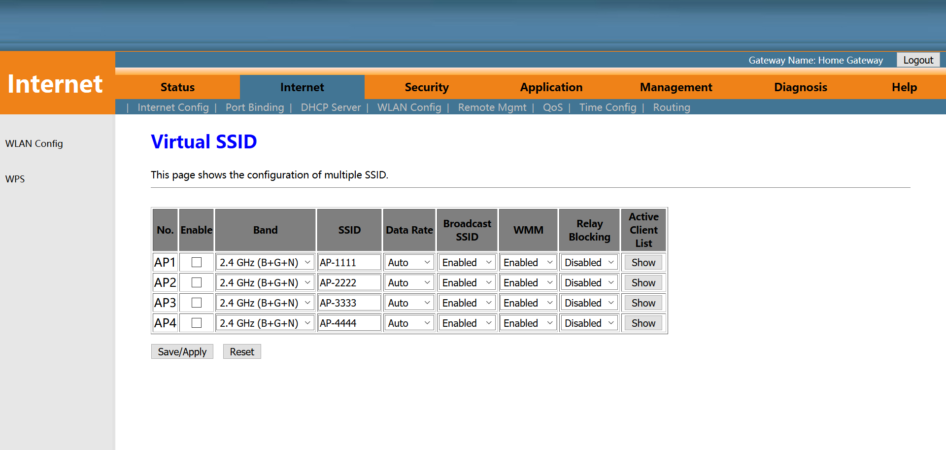

1. After setting wireless password configuration, click ‘**Save/Apply**’ button to finish setting.

**Note:** we can refer to #8.2 about setting the password of virtual SSID.

# CATV Configuration

CATV management is mainly applied to ONU with light machine, we need to configure the ONU optical machine parameters through the ONU’s WEB.

## Configure CATV Port Parameter

Select **Management**🡪**CATV conifg**🡪**CATV config**. In this page, we can enable or disable CATV port and configure the parameters accoding to your requirement. After setting the the parameters, click ‘**Apply Changes**’ button to finish the setting.

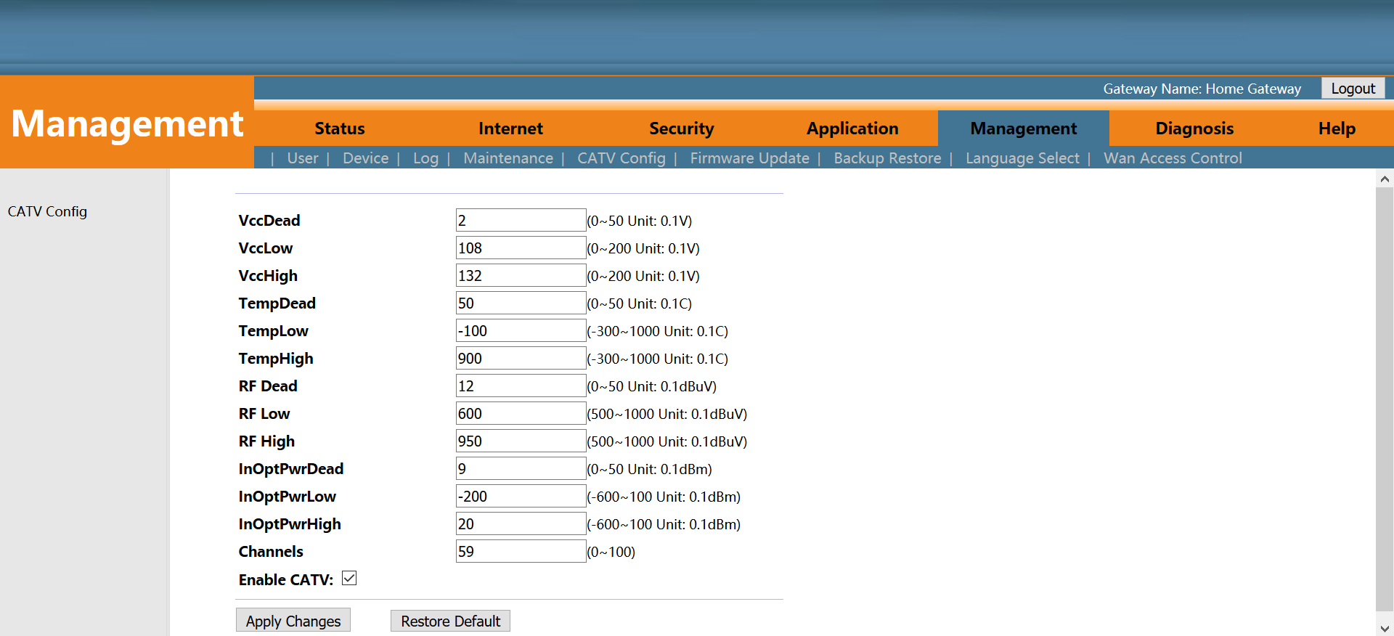

## View CATV Information

1. Login ONU WEB, select **Status**->**Device Info**->**CATV Info**. In this page, we can view the CATV port status and related parameters:

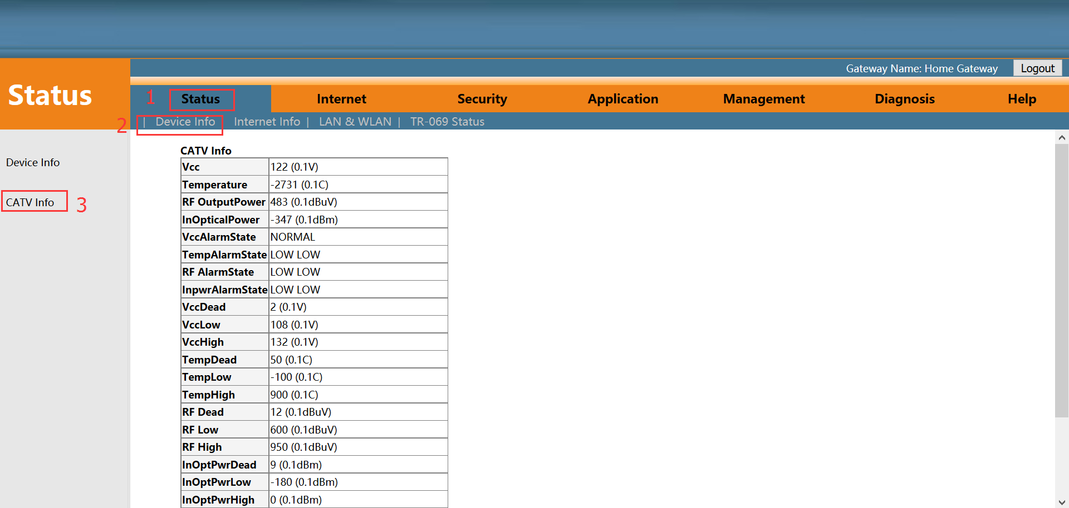

# TR069 Remote Management

ONU TR069 remote management is mainly used for some network that support TR069 server centralized remote management, the current management is mainly used in many large networks, ONU as TR069 remote management of the client need to do the following settings.

## Configure Channel for TR069 Remote Management

Firstly, refered to #**5.1**, set a Route WAN connection with ‘**Service mode**’ as TR069, which is used to act as a channel for TR069 server.

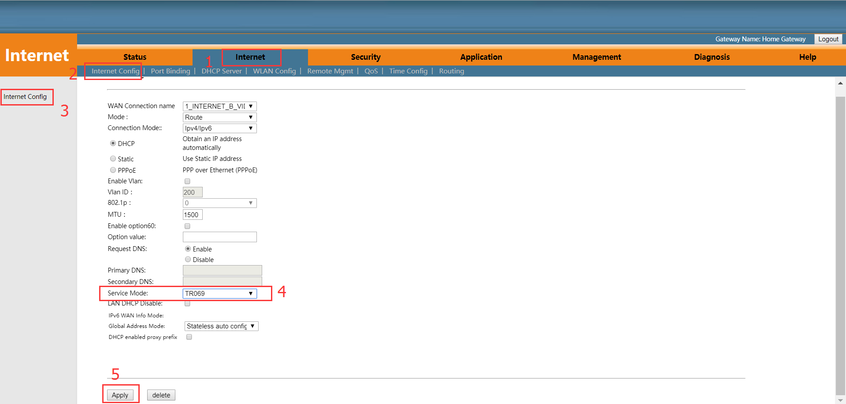

## TR069 Client Configuration

Login ONU WEB, select **Internet-> Remote Mgmt -> ITMS Server**. In this page, we can set ONU’s paremeter of TR069 client (User Name, Password, URL address, Connection request user name and Connection request password).

Note: All of parameters of TR069 are offered by ISP.

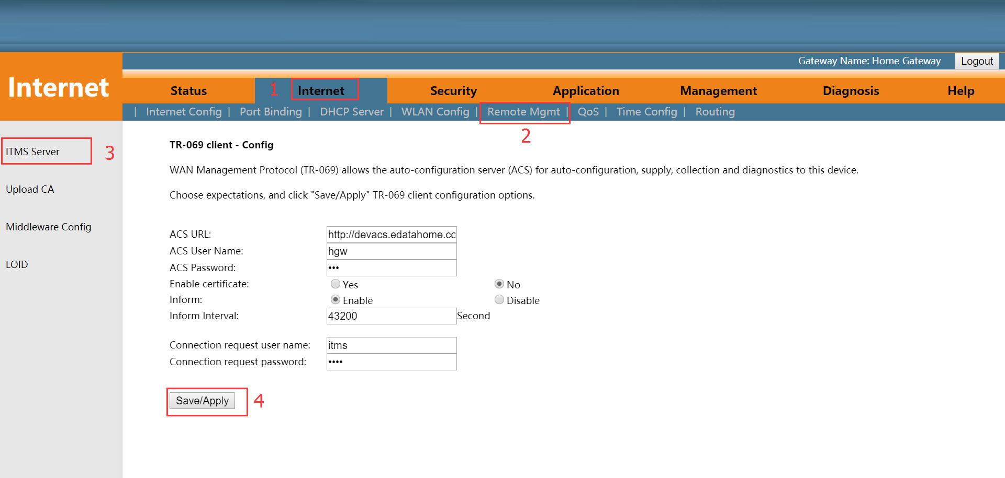

# Device Management

## ONU Remote Access Configuration

Login the ONU WEB, select **Management -> Wan Access Control -> Wan Access Control**. In this page, we can enable or disable the ping remote access and WEB remote access of ONU.

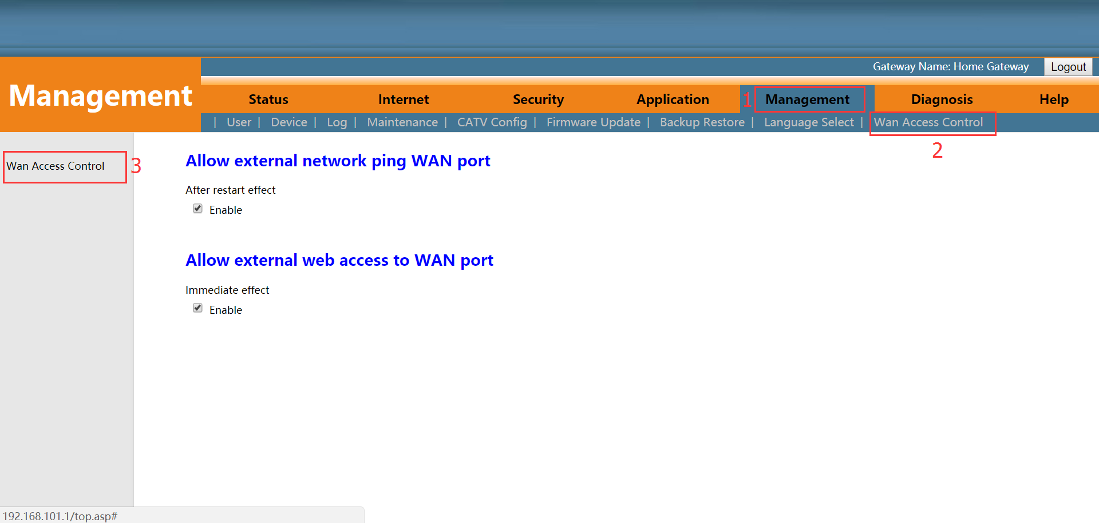

## Restore Default Setting

Login the ONU WEB. Select **Management** -**> Device ->** **Restore ONU**. Click ‘**Restore Default Setting**’ button. The device will restore the factory defaults after the application.

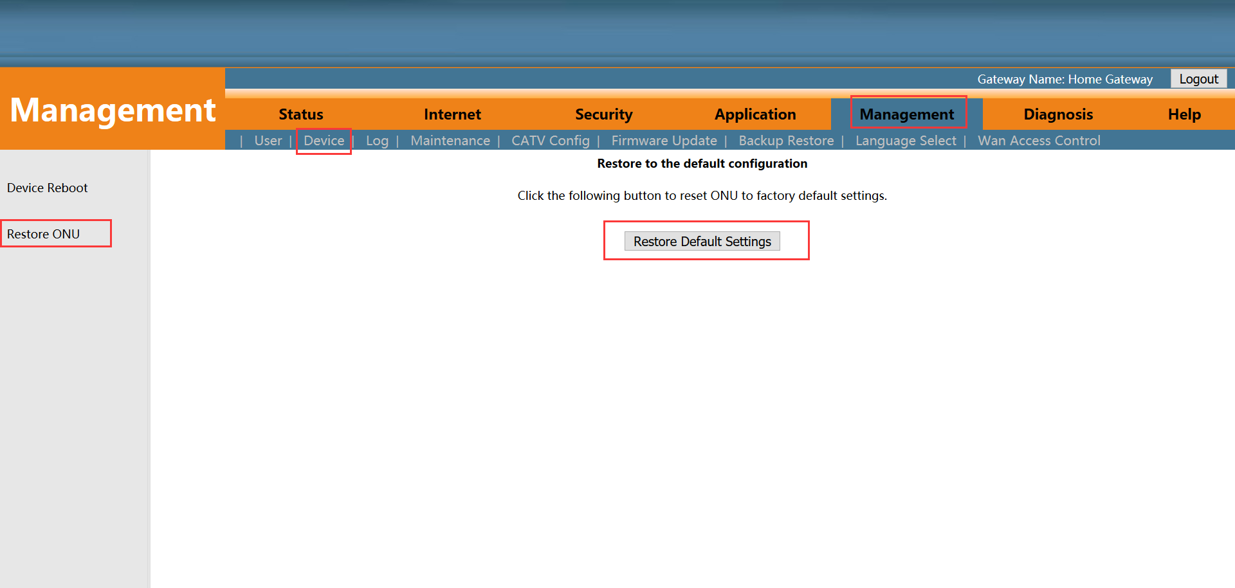

**Note:**Restore Setting on the ONU WEB is take effect to WIFI information of ONU and LAN port configuration only. It doesn’t take any effect to WAN connection.

## Firmware Upgrade

Login the ONU WEB. Select **Management** -> **Firmware Upgrade** -> **Firmware Update**. Click ‘**select files**’ to select firmware file, click ‘**upgrade**’ button to upgrade the ONU. After the application, the device is upgraded to the latest software version.

**Note:** We needn’t extract Realtek project production’s firmware, just upgrade the .tar file. It will take 4 minutes to upgrade. After upgrading, the ONU will reboot automatically. We needn’t reboot it by manual.

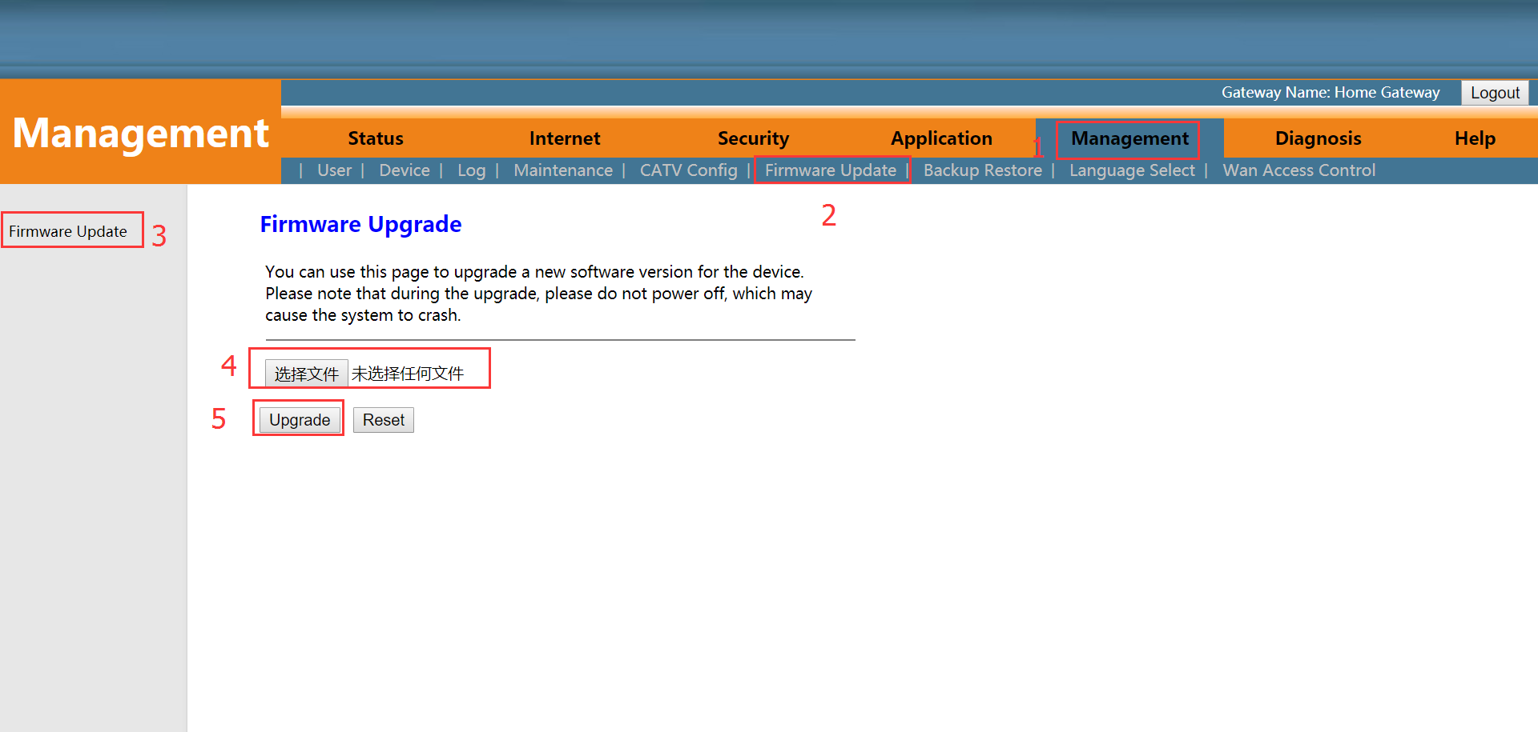

## Device Reboot

Login the ONU WEB. Select **Management** ->**Device->Device Reboot**. Click ‘**Save/Restart**’. Restart the device immediately after application.

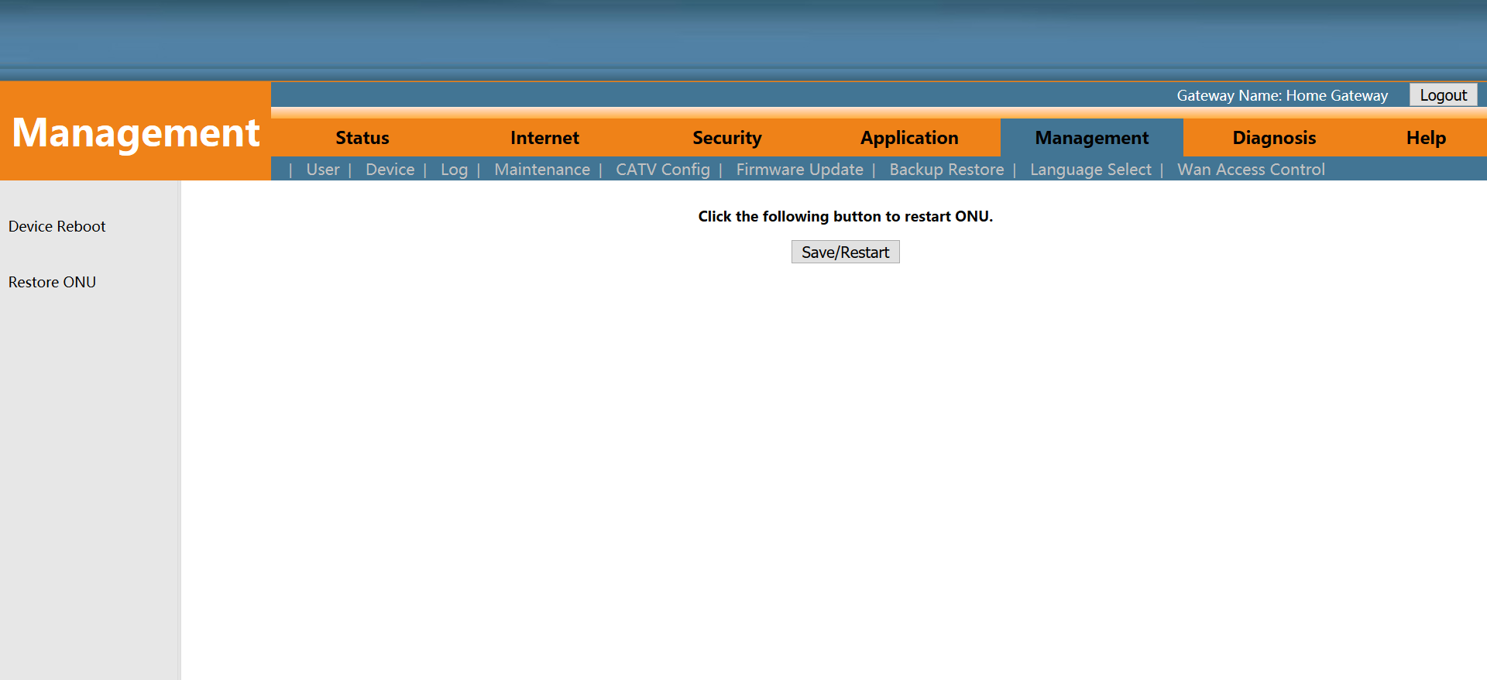

# Concluding Remarks

Thanks for using products of Shenzhen Wodaplug Technology Co. Ltd.

Contact Information:

Company Address: 6th floor, Building 4 of South Area 2, Honghualing Industrial Park, Xili Avenue, Nanshan District, Shenzhen, China

Factory Address: 1st floor, Building B, Wentao Industrial Park, Yingrenshi Community, Shiyan Avenue, Baoan District, Shenzhen, China

Telephone: 0755-26014509/26014710/26014711

Fax: 0755-26014506

Email: [Marketing@cdatatec.com](mailto:Marketing@cdatatec.com)

Website: [www.cdatatec.com](http://www.cdatatec.com)

[www.cdatatec.com.cn](http://www.cdatatec.com.cn)